**GSM**

(GLOBAL SYSTEM FOR MOBILES)

**COMSATS University Islamabad**

Sahiwal Campus



**Usama Sarwar**

FA17-BS(CS)-090-B

**Usman Nasir**

Introduction to ICT

November 03, 2019

Table of Contents

1. Introduction 1

2. History 2

2.1 1981 - 1989 2

2.2 1990 - 1994 3

2.3 1995 - 1999 4

2.4 2000 - 2004 4

2.5 2005 - 2009 4

2.6 2010 - 2015 4

2.7 2016 - 2019 5

3. Architecture 5

4. Benefits 6

4.1 Switching 6

4.2 Choosing 6

4.3 Concurrent Voice & Data 7

4.4 Speed 7

4.5 4G LTE 7

5. Applications 8

6. Challenges 9

7. Future Directions 10

List of Figures

Figure 1. Logo of GSM 1

Figure 2. GSM Era 1

Figure 3. GSM Critical Moments 2

Figure 4. Structure of a GSM Network 6

Figure 5. 4G LTE Technology Logo 7

GSM

(GLOBAL SYSTEM FOR MOBILES)

[](https://www.google.com/url?sa=i&source=images&cd=&cad=rja&uact=8&ved=2ahUKEwjNhIag1M7lAhUhyoUKHaWwAdkQjB16BAgBEAM&url=https%3A%2F%2Fcommons.wikimedia.org%2Fwiki%2FFile%3AGSM222.jpg&psig=AOvVaw1xBhBtQB0q6O6OaN1hjm7b&ust=1572891650984806)

Figure 1. Logo of GSM

# Introduction

GSM (Global System for Mobile communication) may be a numerical mobile network that's wide utilized by mobile users in Europe & alternative components of globe. GSM uses a variation of your time separation multiple access (TDMA) & is that most generally used of 3 numerical wireless telephone technologies: TDMA, GSM & code-division multiple access (CDMA). GSM digitizes & wrappings knowledge, then sends That down a channel with 2 alternative streams of user knowledge, every in its time interval. That operates at either 900 megacycles per second (MHz) or one,800-megahertz waveband. GSM, besides different technologies, is a component of evolution of wireless mobile communications that has High-Speed Circuit-Switched knowledge (HSCSD), General Packet Radio Service (GPRS), increased knowledge GSM surroundings (EDGE) & Universal Mobile Broadcastings Service (UMTS).(Hillebrand 2002)

[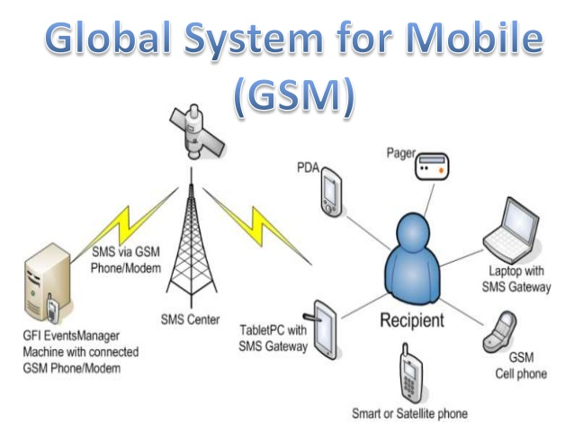](https://www.google.com/url?sa=i&source=images&cd=&ved=2ahUKEwi7stXU1M7lAhVHPBoKHeAKDnIQjRx6BAgBEAQ&url=https%3A%2F%2Fwww.slideshare.net%2FAakankshaR%2Fwireless-49039534&psig=AOvVaw1xBhBtQB0q6O6OaN1hjm7b&ust=1572891650984806)

Figure 2. GSM Era

# History

GSM, is a standard established by European Telecommunications Standards Institute to describe protocols for second cohort digital cellular systems used by mobile phones. That is factual world standard for mobile communications with over ninetieth market share, & is obtainable in over 219 countries & territories. GSM normal was developed as a replacement for 1st group analog cellular networks, & originally represented a digital, circuit-switched network optimized for full duplex voice telephony. This was dilated over time to include info communications, 1st by circuit-switched transport, then packet information transport via GPRS & EDGE. Subsequently, 3GPP developed third generation UMTS morals followed by fourth generation LTE Progressive standards, which are not part of ETSI GSM standard. "GSM" is an emblem preserved by GSM Association. That may also state to originally most mutual voice codec used, Full Rate. (Popoola, Megbowon et al. 2009)

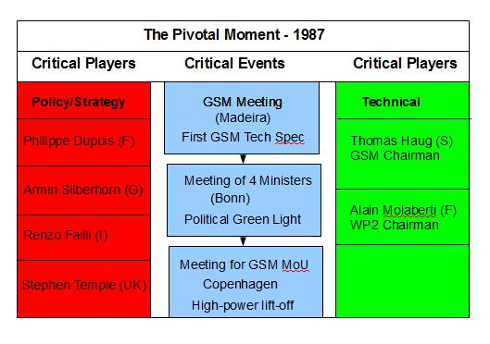

Figure 3. GSM Critical Moments

## 1981 - 1989

History In 1981, work started to develop a European normal for digital cellular voice telephony when European Conference of Postal & Communications Administrations created Groupe Special Mobile group & later provided a permanent technical support cluster primarily based in Paris. (Mouly, Pautet et al. 1992)

Five years later, in 1987, fifteen legislatures from thirteen European countries signed a memo of understanding in Copenhagen to develop & deploy a typical wireless telephone system across Europe, then EU rules were passed to form GSM a compulsory normal. decision to develop a continental normal ultimately resulted in a very unified, open, standard-based network that was larger than that within US. In 1989, Groupe Special Mobile committee was transferred from CEPT to ECU Telecommunications Standards Institute.

In 1987 Europe created terribly 1st united GSM Technical Specification in February. Ministers from four massive EU countries cemented their political support for GSM with urban center Declaration on international info Networks in could & also GSM MoU was tabled. MoU drew-in mobile operators from across Europe to pledge to speculate in new GSM networks to associate degree bold common date. In this short 37-week period whole of Europe had been brought behind GSM in a rare unity & speed guided by four public officials Armin Silber horn, Stephen Temple. (Kumar 2004)

In 1989 Groupe Special Mobile committee was transferred from CEPT to EU Telecommunications Standards Institute. In parallel, France & Federal Republic of Germany signed a joint development agreement in 1984 & were joined by European nation & also Britain in 1986. In 1986 EU Commission planned to reserve 900 MHz spectrum band for GSM.

## 1990 - 1994

Phase I of GSM stipulations were revealed in 1990. world's 1st GSM decision was created by previous Finnish prime minister Harri Holkeri to Kaarina Suonio on Dominion Day, 1991, on a network engineered by Telenokia & subsequent year in 1992, first short messaging service communication was sent & Vodafone UK & Telecom Finland signed first international roaming agreement. Work began in 1991 to expand GSM normal to 1800-megahertz band & also 1st 1800-megahertz network became working within United Kingdom by 1993. Also, that year, telecommunication Australia became first network operator to deploy a GSM network outside Europe & also first sensible hand-held GSM mobile became out there. (Popoola, Megbowon et al. 2009)

## 1995 - 1999

In 1995, fax, knowledge & SMS electronic messaging services were launched commercially, primary 1900 Mc GSM network became operational within US & GSM subscribers worldwide exceeded ten million. Also, this year, GSM Association was fashioned. Pre-paid GSM SIM cards were launched in 1996 & worldwide GSM subscribers passed one hundred million in 1998. (Kingdon, Zadeh et al. 2002)

## 2000 - 2004

In 2000, first business GPRS services were launched & also first GPRS compatible handsets became out there available. In 2001 primary UMTS network was launched, a 3G technology that's not a part of GSM. In 2002 first multimedia system electronic messaging Service was introduced & also first GSM network within 800 Mc band became operational. EDGE services 1st became operational in an exceeding network in 2003 & also range of worldwide GSM subscribers exceeded one billion in 2004. (Kingdon, Zadeh et al. 2002)

## 2005 - 2009

By 2005, GSM networks accounted for over seventy-fifth of worldwide cellular network market, serving 1.5B subscribers. In 2005 primary HSDPA capable network conjointly became operational. first HSUPA network was launched in 2007. High-Speed Packet Access & its transmission & downlink versions area unit 3G technologies, not a part of GSM. Worldwide GSM subscribers surpassed 3 billion in 2008. (Popoola, Megbowon et al. 2009)

## 2010 - 2015

GSM Association calculable in 2010 that technologies outlined within GSM normal serve eightieth of world mobile market, encompassing over five billion individuals across over 212 countries & territories, creating GSM foremost present of various standards for cellular networks. That is vital to notice that GSM may be a second-generation normal using Time-Division Multiple-Access spectrum-sharing, delivered by ECU Telecommunications Standards Institute. GSM normal doesn't embody 3G UMTS CDMA-based technology nor 4G LTE OFDMA-based technology standards issued by 3GPP. Macau planned to terminate its 2G GSM networks as of June four, 2015, creating That primary region to decommission a GSM network.(Antolín, Medrano et al. 2016)

## 2016 - 2019

There are a unit 5 completely different cell sizes during a GSM network—macro, micro, Pico, Femto, & umbrella cells. coverage space of every cell varies per implementation surroundings. Macro-cells is considered cells wherever bottom station antenna is put in on a mast or a building on top of average upper side level. small cells area unit cells whose antenna height is underneath average upper side level; they're usually employed in urban areas. Picocells area unit tiny cells whose coverage diameter could be a few dozen meters; they're in main used inside. Femtocells area unit cells designed to be used in residential or tiny business environments & hook up with service provider’s network via a broadband web association. Umbrella cells area unit accustomed cowl shaded regions of smaller cells & fill in gaps in coverage between those cells. Cell horizontal radius varies reckoning on antenna height, antenna gain, & propagation conditions from a handful of hundred meters to many tens of kilometers. longest distance GSM specification supports in sensible use is thirty-five kilometers. (Semama & DAVID 2019)

# Architecture

There are two main parts of a GSM System: First one is known as Base Station Subsystem or BSS or also known as access network. & other main part is Network Subsystem or NSS or Core Network Now, why Base Station Subsystem (BSS) is called Access Network. BSS is called as Access Network as Mobile connects to Access Network, to communicate with GSM Network. Now, whenever a mobile user (or a mobile subscriber) wants to make a call or avail any of services of network. That needs a SIM to use mobile. Now, here That is important to differentiate between two identities. One is identity of mobile station itself, which is its IMEI (International Mobile Equipment Identity) number. & second one is identity of SIM, or in other words of subscriber who is using mobile. & this identity I characterized by IMIS (International Mobile Subscriber Identity) So, when a mobile user wants to use network, he needs a SIM with a valid IMSI burned into That. &, then this user can use this SIM in mobile having a valid IMEI number, to make a call etc. Now when mobile user wants to connect to a network or make a call Then he will use his mobile Station to connect to Base Station (also known as BTS). & he makes this connection over Radio Interface, which is also known as Air Interface. & That is denoted as Um. So, Radio or Air Interface is denoted as Um Now, talking about Base Station Subsystem (BSS), you can see that here we have BTSs.

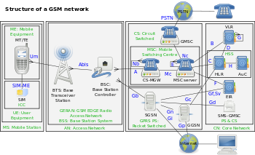

Figure 4. Structure of a GSM Network

# Benefits

Global System for Mobiles is that primary technology used globally for 3G mobile networks, with a couple of seventy three percent market share. GSM competes primarily with Code Division Multiple Access technologies, that is that technology employed by 5 of seven largest transporters within U.S. whereas GSM delivers compatibility, multitasking & speed benefits over CDMA on a 3G network, most carriers round world are switch to future Evolution customary for their 4G networks.

## Switching

Every GSM phone has a global Module arrangement identification number to spot telephone set. GSM additionally uses a Subscriber Identity Module card to store a customer's account info. If you purchase a brand-new GSM phone, you'll merely take away SIM card from your recent phone, place That in your new phone & start victimization new phone promptly. you're not needed to register new phone's IMEI variety with a GSM supplier. (Sutton 2020)

## Choosing

ease of switch handsets & also dominance of GSM mobile networks globally offer customers with a bigger choice of phones to settle on from. However, whereas you'll usually use a GSM phone on any carrier's 3G GSM network in Europe, that is not conjointly true within us. ATandT & T-Mobile, two U.S. GSM carriers, use totally different frequencies for his or her 3G networks. A 3G T-Mobile phone may connect with ATandT network, however That in all probability will not be able to transmit voice or information on correct frequencies to figure well & may revert to 2G speeds. (Sutton 2020)

## Concurrent Voice & Data

When you use a GSM network, you'll speak on phone & surf net or adjust your email at identical time. that is typically not a possibility if you are employing a phone on a CDMA network. CDMA free an add-on possibility known as cooccurring Voice & information improvement that might modify callers to use voice & information at identical time, however add-on would need changes to each CDMA network & CDMA phones. Carriers within us haven't adopted add-on for his or her networks. (Sutton 2020)

## Speed

A GSM network is usually abundant quicker than a CDMA network. Most GSM carriers adopted High-Speed Packet Access extension for 3G networks that modify information transfers as quick as 42Mbps. On a 3G CDMA network, utmost information transfer rate is 3.6Mbps. (Sutton 2020)

## 4G LTE

Most carriers have adopted LTE commonplace for their 4G networks, that allows in no time cooccurring transfers of each voice & information. However, all U.S. carriers can keep their 3G networks in place till a minimum of 2020. Customers who board a locality while not 4G coverage can have to be compelled to still use a 3G network. iPhone users can need to upgrade to iPhone five or a later version to use popular phone on a 4G network. (Sutton 2020)

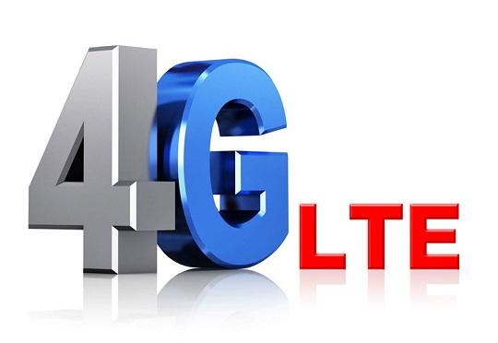

Figure 5. 4G LTE Technology Logo

# Applications

GSM frequency usage, see GSM frequency bands. despite frequency designated by Associate in Nursing operator, That's divided into timeslots for individual phones. this permits eight full-rate or sixteen half-rate speech channels per oftenest. These eight radio timeslots area unit sorted into a TDMA frame. Half-rate channels use alternate frames within same timeslot. station rate for all eight channels is 270.833 Kbit/s, & therefore frame length is four.615 MS broadcast power within telephone set is proscribed to a most of two watts in GSM 850/900 & one watt in GSM 1800/1900. Voice codecs GSM has used a spread of voice codecs to squeeze three.1 kilocycle audio into between half-dozen.5 & thirteen Kbit/s. Originally, two codecs, named when kinds of information channel they were allotted, were used, recognized as 0.5 Rate & Full Rate. These used a system supported linear prognostic writing. additionally, to being economical with bitrates, these codecs additionally created That easier to spot additional vital components of audio, permitting air interface layer to priorities & higher defend these components of signal. As GSM was more increased in 1997 with improved Full Rate codec, a 12.2 Kbit/s codec that uses a full-rate channel. Finally, with event of UMTS, EFR was refactored into a variable-rate codec known as AMR-Narrowband, that is prime quality & sturdy against interference once used on full-rate channels, or less sturdy however still comparatively prime quality once employed in smart radio conditions on half-rate channel. Subscriber Identity Module one in each of key options of GSM is that Subscriber Identity Module usually referred to as a SIM card. SIM could be a clastic positive identification containing user's subscription info & phone book. this enables user to retain his or her info when shifting handsets. instead, user may also modification operators whereas retentive telephone set just by dynamic SIM. Some operators can block this by permitting phone to use solely one SIM, or solely a SIM issued by them; this applies is understood as SIM lockup. Phone lockup generally mobile network operators prohibit handsets that they sell to be used with their own network. this can be known as a lockup & is enforced by a software system feature of phone. A subscriber might typically contact supplier to get rid of lock for a fee, utilize non-public services to get rid of lock, or use software system & websites to unlock telephone set themselves. In some countries, all phones area unit sold unfastened. In others, That's unlawful for operators to supply any sort of grant on a phone's value. GSM service security GSM was designed with a moderate level of service security. system was designed to attest subscriber employing a pre-shared key & challenge-response. Communications between subscriber & therefore base station are encrypted. event of UMTS introduces Associate in Nursing elective Universal Subscriber Identity Module, that uses an extended authentication key to offer larger security, yet as reciprocally authenticating network & therefore user, whereas GSM solely authenticates user to network. protection model so offers confidentiality & authentication, however, restricted authorization capabilities, & no non-repudiation. GSM uses many crypto logical algorithms for security. A5/1, A5/2, & A5/3 stream cyphers area unit used for making certain over- -air voice privacy. (Semama & DAVID 2019)

# Challenges

He additionally aforesaid that That's attainable to create "a full GSM fighter aircraft from ASCII text file components" however that they'd not done thus attributable to legal considerations. season claimed that he was ready to intercept voice & text conversations by impersonating another user to concentrate to voicemail, make calls, or send text messages employing a seven-year-old Motorola radiotelephone & secret writing code obtainable at no cost on-line. New attacks are discovered that profit of poor security implementations, design, & development for smartphone applications. Some wiretapping & eavesdropping techniques hijack audio input & output providing a chance for a 3rd party to concentrate in to speech. GSM uses General Packet Radio Service for knowledge transmissions like browsing online. foremost normally deployed GPRS ciphers were in public broken 2011. researchers disclosed flaws within normally used GEA/1 & GEA/2 ciphers & revealed ASCII text file "precede" code for sniffing GPRS networks. They additionally noted that some carriers don't code info so as to observe employment of traffic or protocols they are doing not like, deed customers unprotected. GEA/3 looks to stay comparatively arduous to interrupt & is alleged to be in use on some additional trendy networks. If used with USIM to stop connections to faux base stations & downgrade attacks, users are going to be protected within medium term, ' migration to 128-bit GEA/4 continues to be suggested. Standards info GSM systems & services are delineating in a very set of standards ruled by ETSI, wherever a full list is maintained. GSM ASCII text file code many ASCII text file code comes exist that offer sure GSM features: gem daemon by Openmoko OpenBTS develops a Base transceiver station GSM code Project aims to create a GSM analyzer for fewer than $1,000 OsmocomBB developers shall replace proprietary baseband GSM stack with a free code implementation problems with patents & open supply Patents stay a tangle for any ASCII text file GSM implementation, as a result of That's insufferable for antelope or other free code distributor to ensure immunity from all lawsuits by patent holders against users. what are more new options are being intercalary to quality all time which suggests they need patent protection for variety of years. first GSM implementations from 1991 could currently be entirely freed from patent encumbrances, but patent freedom isn't sure because of United States' "first to invent" system that was in situ till 2012. "first to invent" system, including "patent term adjustment" will extend lifetime of a U.S. patent so much on far side twenty years from its priority date. That's unclear at now whether or not OpenBTS are going to be ready to implement options of that initial specification while not limit. As patents later on expire, however, those options are often intercalary into ASCII text file version. As of 2011, there are no lawsuits against users of OpenBTS over GSM use. (Rehmani & Dhaou 2019)

# Future Directions

In an attempt to allocate spectrum, several carriers are setting target dates to try to away with GSM networks. That seems that 2017 are going to be year that GSM can take its place within mobile network hereafter, however, That's going to surprise you way several devices still treat 2G network. Three operators in Singapore are most recent to announce plans to show off their GSM networks, setting a date of Apr 1, 2017. Australian carrier Telstra already declared their plans to drag plug on second-generation network by tip of 2016. ATandT has set a target date of Jan. 1, 2017. For most customers, this may not cause abundant of a ripple in their mobile consciousness as a majority are already on 3G & 4G networks, however, That may mean hassle for machine-to-machine connections. Because several of M2M devices, like vehicle alarms & rendition machines, last longer than your typical cell, they still use GSM networks for his or her transmission wants. there have been still regarding a hundred & sixty million GSM-connected devices at tip of last year, in step with Machina analysis. Matt Hatton, chief operating officer of Machina aforesaid chipmakers are engaged on cheaper LTE modems, however, bulk of new M2M devices still treat GSM. In spite of this, carriers have a large incentive to disconnect their GSM networks. Turning them off means that they'll apportion spectrum to 3G & 4G networks, permitting them to use spectrum a lot of with efficiency. this suggests they'll serve a lot of customers & convey in additional revenue. But not all carriers are in such a rush to chop twine on GSM. French operator Orange has no immediate plans for end of their GSM network, in step with Yves Bellego, director of technical & network strategy at Orange. Norwegian operator Telenor recently proclaimed plans to show off its 3G network before its GSM, targeting 2020 for previous & 2025 for latter. That’s no coincidence that European carriers are in less of a rush to try to away with GSM as there's still plenty of cash to be created on roaming. Hatton aforesaid they will conjointly run into some regulative problems. (Sutton 2020)

References

Antolín, D., et al. (2016). "Reliable lifespan evaluation of a remote environment monitoring system based on wireless sensor networks & global system for mobile communications." Journal of Sensors **2016**.

Hillebrand, F. (2002). GSM & UMTS: creation of global mobile communication, Wiley Chichester.

Kingdon, C. H., et al. (2002). System & method for provisioning assistance global positioning system information to a mobile station, Google Patents.

Kumar, S. (2004). "Mobile communications: global trends in 21st century." International Journal of Mobile Communications **2**(1): 67-86.

Mouly, M., et al. (1992). GSM system for mobile communications, Telecom publishing.

Popoola, J., et al. (2009). "Performance evaluation & improvement on quality of service of global system for mobile communications in Nigeria." Journal of Information Technology Impact **9**(2): 91-106.

Rehmani, M. H. & R. Dhaou (2019). Cognitive Radio, Mobile Communications & Wireless Networks, Springer.

Semama, M. & I. DAVID (2019). System & method for global location register (GLR) for LTE/4G mobile network, Google Patents.

Sutton, A. (2020). " FUTURE OF MOBILE COMMUNICATIONS."